SPECIFIC HEAT
Directions:
1. Light the candle.
2. Hold both the glass rod and copper rod just above the flame at equal distances for no more than 8-9 seconds.
*BE CARFUL. It’s HOT!
3. WAIT 30 seconds and gently feel the tips of both the glass rod and copper rod.
4. Which one feels warmer? Which one feels cooler?
5. Complete the physical properties chart.
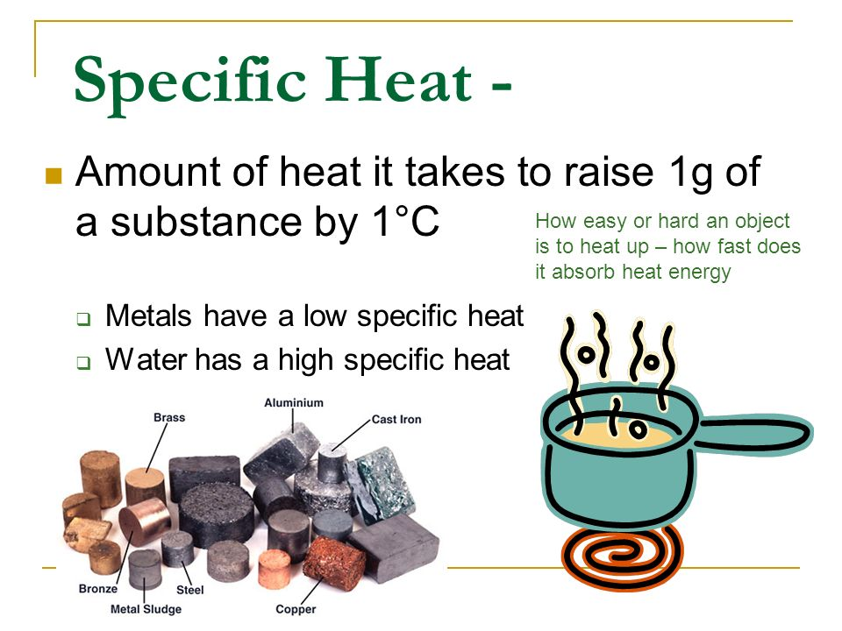
Conductivity
Directions:
1. Use the small glass rod to complete the circuit. Did the light bulb light up?
2. Use the aluminum rod to complete the circuit. Did the light bulb light up?
3. Which object is conductive of electricity?
4. Which object would be a good insulator?

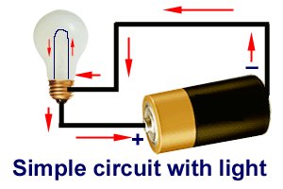
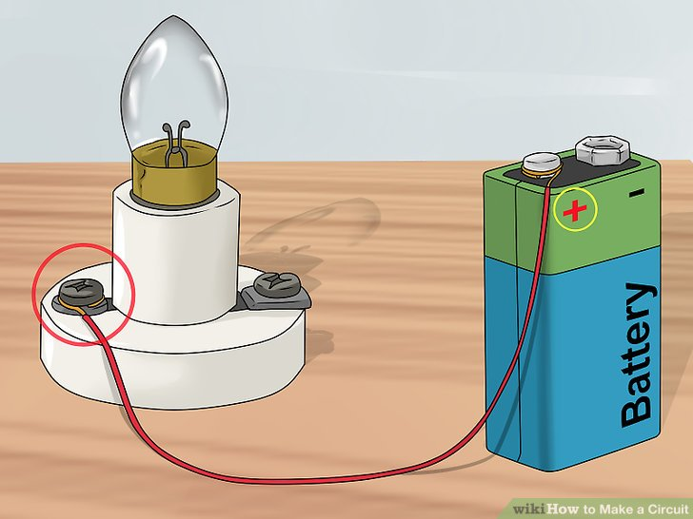
Density D=M/V
Directions
1. Find the mass of the metal (copper) cube.
2. Find the volume of the metal cube (L * W * H).
3. Calculate the density of the metal cube.
4. Repeat steps 1-3 for the wooden cube.
5. Predict which cube will sink in water.
6. Test your hypothesis.
7. Which cube is more dense? How do you know?
8. Clean up
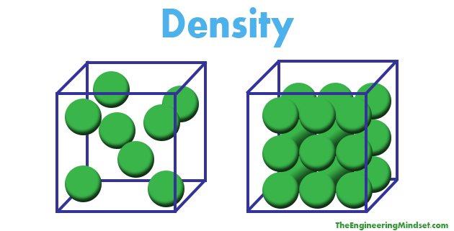

Magnetism
DIrections
1. Using the magnet, test coin one. Is it magnetic?
2. Using the magnet, test coin two. Is it magnetic?

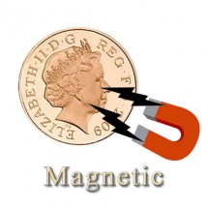

Sound
Directions
1. Using the tuning fork, tap coin 3. What kind of sound does it make?
2. Now, tap coin 3 on the table. What kind of sound does it make?
3. Using the tuning fork, tap coin 4. What kind of sound does it make?
4. Now, tap coin 4 on the table. What kind of sound does it make?
5. Which coin made a ringing sound when tapped on the table and tuning fork?
6. Which coin made a dull thud sound when tapped on the table and tuning fork?
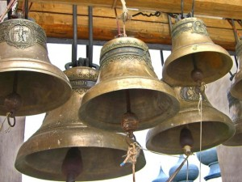
Malleability
Directions
1. Test whether the following substances are considered to be malleable or brittle.
2. Using the aluminum foil and plastic butter knife, see which one bends or breaks.
3. Which object is malleable? Which object is brittle? How can you tell?
4. Prediction: If you hit each object with a hammer. Which object would bend? Which object would crack?

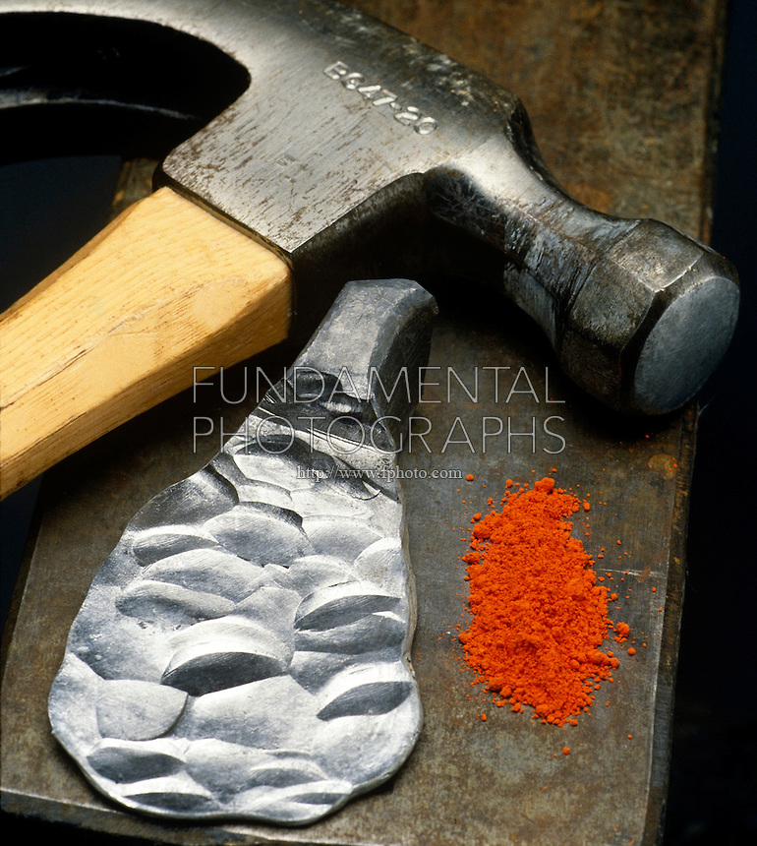
Crystalline Structure
Directions
1. Use the magnifying glass to observe each substance.
2. Can you determine the following substances based on their structure?
*Metamorphic rock – a rocky mixture of crystals that have been smashed.
*Quartz – long clear-ish crystals
*Bismuth – boxy crystals
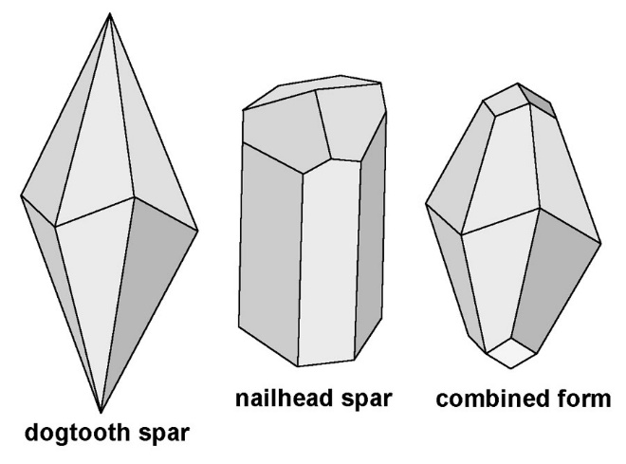
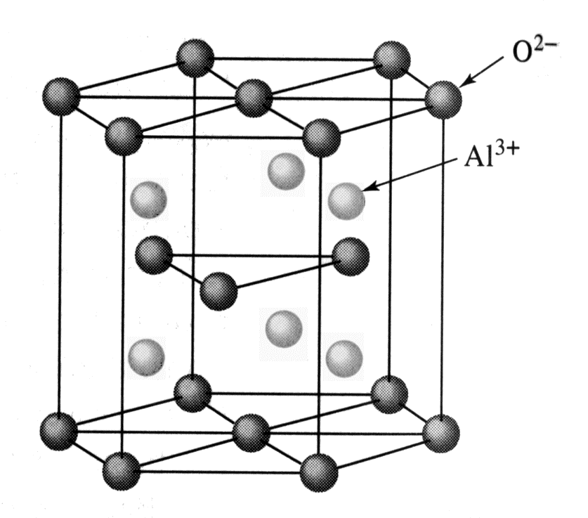
State of Matter
Directions
Mercury:
1. Observe the sample of mercury in the sealed container. Do not open!
2. View the element card for mercury. All the information about mercury can be found on the back of the card.
3. What state of matter is mercury at room temperature?
Water:
4. Observe the sample of water in the bottle.
5. View the molecule card for water. All the information about water can be found on the back of the card.
6. What state of matter is water at room temperature?
Video:
7. Choose one of the following Discovery Education videos to watch.
a) Forms of Matter (1:09)
or
b) States of Matter (3:10)

