Literacy Activity: The Chesapeake Bay: Description Wheel 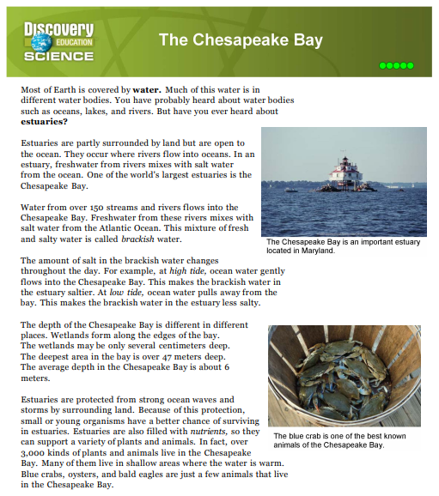
Directions: Follow the procedures to complete the following literacy activity correctly.
1. Close Read the article, “The Chesapeake Bay” in small cooperative groups
2. Create a descriptive wheel like the one on the next page. Use adjectives and prepositions to complete the descriptive wheel.
Adjective:
Preposition:
3. Annotate your answers throughout the article by highlighting the text where you pulled your information. Circle 3 unfamiliar words found in the article and describe the meaning of the words using text from the article (off to the side of the article).

Descriptive wheel: create the following graphic on a separate sheet of paper. Use adjectives and prepositions to complete the graphic correctly. Extension: include one picture for each adjective and/or preposition used to describe the Chesapeake Bay.
The Chesapeake Bay

