Chemical Formulas: Coefficients and Subscripts Name: ____________________
Make Up Assignment Block: ____________________
Substance  Chemical Formula | Total Number of Molecules | Total Number of  Atoms (O) Oxygen | Total Number of Atoms (C) Carbon | Total Number of Atoms (H) Hydrogen
5H2SO4
12C2H5OH
2H2CO3
NaC2H3O2
4K2CO3
3Na2SO4
3NaHCO3
4Fe2O3
4Ca(OH)2

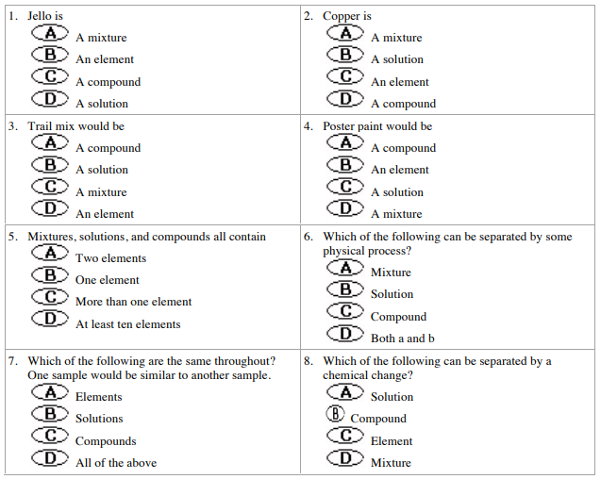
Chemical Formulas: Coefficients and Subscripts Name: ____________________
Make Up Assignment Block: ____________________
Substance  Chemical Formula | Total Number of Molecules | Total Number of  Atoms (O) Oxygen | Total Number of Atoms (C) Carbon | Total Number of Atoms (H) Hydrogen
5H2SO4
12C2H5OH
2H2CO3
NaC2H3O2
4K2CO3
3Na2SO4
3NaHCO3
4Fe2O3
4Ca(OH)2

