Water 1: Study Guide NAME: ______________ BLOCK: _______
TERMS & CONCEPTS
Directions: Identify the meaning and/or importance of the following concepts. Write 1-3 sentences for each.
 | TERM | DEFINITION
1 | spring
2 | runoff
3 | groundwater
4 | river basin vs. watershed
5 | saturated vs. unsaturated zone
6 | solvent vs. solute vs. solution
7 | distribution of Earth’s water
8 | salinity
REFLECTION QUESTIONS:
9. Explain the steps water goes through as it moves through the water cycle.

10. Explain the difference between Permeable/Impermeable.

11. What is the universal solvent? Why?

12. List the 2 types of estuaries. How are they different? How are they similar?

13. How does precipitation get from a divide down to a river and into the ocean.

15. How does most salt get into the ocean?

16. Why are estuaries called the nurseries of the ocean?

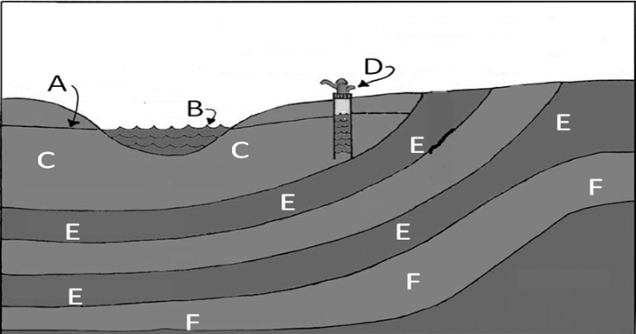
17. LABEL parts A-F using these terms:
permeable rock: _______ impermeable rock: _______ water table: _______
surface water: _______ well: _______ confined aquifer: _______

18. Where would the unsaturated zone be located in the picture above?

19. What does the impermeable rock layer do within an aquifer?

20. Where does the water in the aquifer come from?

