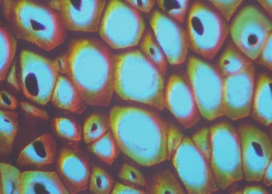
Unit 1E Biology: Cells
Transition Activity: Visual Vocabulary Due: ______________

Subject: Science Notebook Page _____
Unit E
Directions: Write the definition to the following vocabulary words below on page 5 of your Science Interactive Notebook. After writing the definitions draw one picture and color when finished. ONLY 5 WORDS PER PAGE PLEASE!

Vocabulary Words
- Cell theory
- Organelle
- Cell wall
- Cell membrane
- Cytoplasm
- Nucleus
- Prokaryotic
- Eukaryotic
- Chloroplasts
- Mitochondria
- Diffusion
- Osmosis
- Cell respiration
- Photosynthesis
- ATP– adenosine triphosphate

Unit 1E Biology: Cells
Transition Activity: Visual Vocabulary Due: ______________

Subject: Science Notebook Page _____
Unit E
Directions: Write the definition to the following vocabulary words below on page 5 of your Science Interactive Notebook. After writing the definitions draw one picture and color when finished. ONLY 5 WORDS PER PAGE PLEASE!

Vocabulary Words
- Cell theory
- Organelle
- Cell wall
- Cell membrane
- Cytoplasm
- Nucleus
- Prokaryotic
- Eukaryotic
- Chloroplasts
- Mitochondria
- Diffusion
- Osmosis
- Cell respiration
- Photosynthesis
- ATP– adenosine triphosphate

Unit 1E Biology: Cells
Transition Activity: Visual Vocabulary Due: ______________

Subject: Science Notebook Page _____
Unit E
Directions: Write the definition to the following vocabulary words below on page 5 of your Science Interactive Notebook. After writing the definitions draw one picture and color when finished. ONLY 5 WORDS PER PAGE PLEASE!

Vocabulary Words
- Cell theory
- Organelle
- Cell wall
- Cell membrane
- Cytoplasm
- Nucleus
- Prokaryotic
- Eukaryotic
- Chloroplasts
- Mitochondria
- Diffusion
- Osmosis
- Cell respiration
- Photosynthesis
- ATP– adenosine triphosphate

Unit 1E Biology: Cells
Transition Activity: Visual Vocabulary Due: ______________

Subject: Science Notebook Page _____
Unit E
Directions: Write the definition to the following vocabulary words below on page 5 of your Science Interactive Notebook. After writing the definitions draw one picture and color when finished. ONLY 5 WORDS PER PAGE PLEASE!

Vocabulary Words
- Cell theory
- Organelle
- Cell wall
- Cell membrane
- Cytoplasm
- Nucleus
- Prokaryotic
- Eukaryotic
- Chloroplasts
- Mitochondria
- Diffusion
- Osmosis
- Cell respiration
- Photosynthesis
- ATP– adenosine triphosphate

