Literacy Transition – Viruses In Depth
Objectives:
Create comprehensive understanding through text of viruses and the diseases they cause.
Build on prior knowledge and gain an understanding of different types of viruses and the diseases they cause through text.
- Close Reading – Read the assigned article independently. Highlight 5 words associated with microorganisms and disease.
- Think Pair Share – Choose a partner within your group and discuss the terms highlighted within the article. Create a Q H T chart and sort the words accordingly. (Q signals words you do not know, H signals words you might be able to identify, and T signals words you know well enough to teach your peers).
Q –don’t know | H – might know | T – know well
-  - | -  - | -  -
- Use context clues to define each vocabulary word from the article.
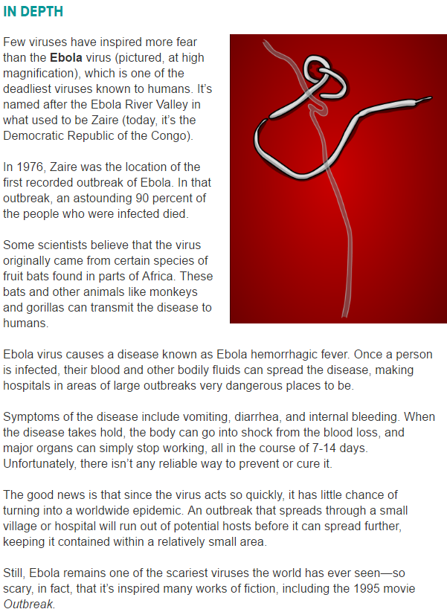

Literacy Transition – Viruses In Depth
Objectives:
Create comprehensive understanding through text of viruses and the diseases they cause.
Build on prior knowledge and gain an understanding of different types of viruses and the diseases they cause through text.
- Close Reading – Read the assigned article independently. Highlight 5 words associated with microorganisms and disease.
- Think Pair Share – Choose a partner within your group and discuss the terms highlighted within the article. Create a Q H T chart and sort the words accordingly. (Q signals words you do not know, H signals words you might be able to identify, and T signals words you know well enough to teach your peers).
Q –don’t know | H – might know | T – know well
-  - | -  - | -  -
- Use context clues to define each vocabulary word from the article.

