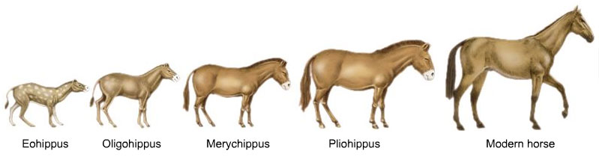
Evolution
Visual Vocabulary
Direction: In your notebook, write the term, definition, and draw a picture for each of the vocabulary terms below. Remember, only 5 words per page and color each picture. This assignment must in you your Science interactive notebook to receive credit. Notebook page _____________ Due: __________________
Terms to know:
- Evolution
- Isolation
- Law of superposition
- Relative age
- Absolute age
- Vestigial organ
- Charles Darwin
- Jean Lamarck
- Natural Selection
- Variation
- Speciation
- (2) Analogous structures verse Homologous structures
- Overproduction
- Mutagen
- Fossil

Evolution
Visual Vocabulary
Direction: In your notebook, write the term, definition, and draw a picture for each of the vocabulary terms below. Remember, only 5 words per page and color each picture. This assignment must in you your Science interactive notebook to receive credit. Notebook page _____________ Due: __________________
Terms to know:
- Evolution
- Isolation
- Law of superposition
- Relative age
- Absolute age
- Vestigial organ
- Charles Darwin
- Jean Lamarck
- Natural Selection
- Variation
- Speciation
- (2) Analogous structures verse Homologous structures
- Overproduction
- Mutagen
- Fossil

Evolution
Visual Vocabulary
Direction: In your notebook, write the term, definition, and draw a picture for each of the vocabulary terms below. Remember, only 5 words per page and color each picture. This assignment must in you your Science interactive notebook to receive credit. Notebook page _____________ Due: __________________
Terms to know:
- Evolution
- Isolation
- Law of superposition
- Relative age
- Absolute age
- Vestigial organ
- Charles Darwin
- Jean Lamarck
- Natural Selection
- Variation
- Speciation
- (2) Analogous structures verse Homologous structures
- Overproduction
- Mutagen
- Fossil

Evolution
Visual Vocabulary
Direction: In your notebook, write the term, definition, and draw a picture for each of the vocabulary terms below. Remember, only 5 words per page and color each picture. This assignment must in you your Science interactive notebook to receive credit. Notebook page _____________ Due: __________________
Terms to know:
- Evolution
- Isolation
- Law of superposition
- Relative age
- Absolute age
- Vestigial organ
- Charles Darwin
- Jean Lamarck
- Natural Selection
- Variation
- Speciation
- (2) Analogous structures verse Homologous structures
- Overproduction
- Mutagen
- Fossil

