EOG REVIEW for BIO/GEO EVOLUTION
Use the following words to fill in the blanks below: CAST INDEX AFRICA VARIATION (2)
LAW OF SUPERPOSITION YOUNGER CONVECTION NATURAL SELECTION CONVERGE
CARBONIZED DIVERGE PRODUCERS TRANSFORM PRECAMBRIAN PHENOTYPE
MULTICELLULAR EARTHQUAKES OXYGEN ABSOLUTE PETRIFIED ADAPTED
PANGAEA DENSE MOLD IRON PRESERVED MESOZOIC ADAPTATIONS
RADIOACTIVE TRACE AMERICA BOTTOM EXTINCTION PALEOZOIC ISOLATION
SUBDUCTION ICE CORES CONTINENTAL DRIFT COMPETE CENOZOIC SPECIATION

The center of earth is made of Fe ( ________), not rocks because it is more __________ than most rocks and it sinks.
In undisturbed sedimentary rock layers the oldest layer is on the __________. This is known as the ________________. Volcanic igneous intrusions, faults or cracks in the rock layers are always __________ than the layers that they cut through. The movement of rising hot magma from the center of the Earth and falling of cooling magma near its crust creates a ______________ current which causes the tectonic plates to move.
Movement of Earth’s numerous plates are responsible for __________________________ over the eons. When plates _______________ they can form mountains or get pushed below one another giving rise to volcanoes. This is known as S________________. In the middle of the ocean, new, thin crust is formed when plates ________________. When plates move against each other, they cause _______________ and trigger tsunamis. We call these ______________ plates.
The first 4 billion years of Earth history is known as the ________________ eon. No _________________ life existed. But unicellular _________________, known as cyanobacteria, did so much photosynthesizing, that the Earth got lots of ______________ for more energetic, advanced life to evolve.
Earth’s first multicellular organisms like early plants, insects and fishes thrived from 550mya to 250mya called the ____________ era. Reptiles like the dinosaurs took over next from 250mya to 65mya during the ______________ era. our current era, ________________, is the age of the mammals like us. This geological time scale is broken into divisions based on fossils evidence and major ____________ events. Fossil and archaeological evidence shows man has only been here a few hundred thousand to a few million years (although how you properly define “man” is still debated in many circles). Modern man has been migrating around Earth only the last 30,000 years. _________________ are fossils of organisms that were widespread but lived for a short period which are used to relatively date rocks layers.
Fill in the six types of fossils below:
_______________ The imprint of a once living thing in a rock
_______________ The 3-D impression of a once living thing made of sedimentary rock
_______________ When the tissues of a once living thing has been replaced with rock-like minerals
_______________ A well preserved tissue that is contained in tar, ice, or amber
_______________ The film left over from a once living thing in which only the carbon outline remains
_______________ Any evidence of a living thing that shows past activity
______________ are used to analyze changes in Earth’s atmosphere over time because they contain air from different periods in Earth’s history.
Similar fossils of plants and animals were found in both South __________ and ___________ & indicate that the two landmasses were once joined together 220 mya (million years ago). We call this once-supercontinent ______________. The amount of Carbon- 14, Uranium-238 and other unstable atoms can be measured in rocks and fossils to give scientists an exact date of ancient things. Also known as ________________ dating, this gives us the A____________ age of a fossil.
The theory of bio evolution states that V________________ among members of a species result in a higher probability that the species will undergo the process of N_________ S__________ if their environment changes. Regardless, organisms must __________ for limited resources (food, shelter, water, and space). Those who are best ____________to their environment will survive to reproduce.
When a members of species are divided or separated from its population, it is known as ______________, and the diversity of the species increases. These organisms take on new variations to better adapt to new their surroundings in order to survive. After many generations of isolation, _____________ can occur; when a new species that is different from the original has emerged with better fitting traits called A_______________.
No two zebras have the same pattern of stripes; this is an example of __________________ within a species. A trait (such as eye color or hair color) that can be identified by physical means is a ____________________.

Identify below these additional pieces of evidence that all living things evolved from a common ancestor: embryos, homologous structures, analogous structures, vestigial organs, transitional fossils, DNA evidence
________________ Structures SO similar between different species (see below)
________________ A shrunken or unused body part that is still present in an organism
________________ Comparing the similar genes of similar organisms
________________ Comparing the way so much life looks the same at the beginning
________________ Uncovering layers of Earth showing how a species could have evolved over a long time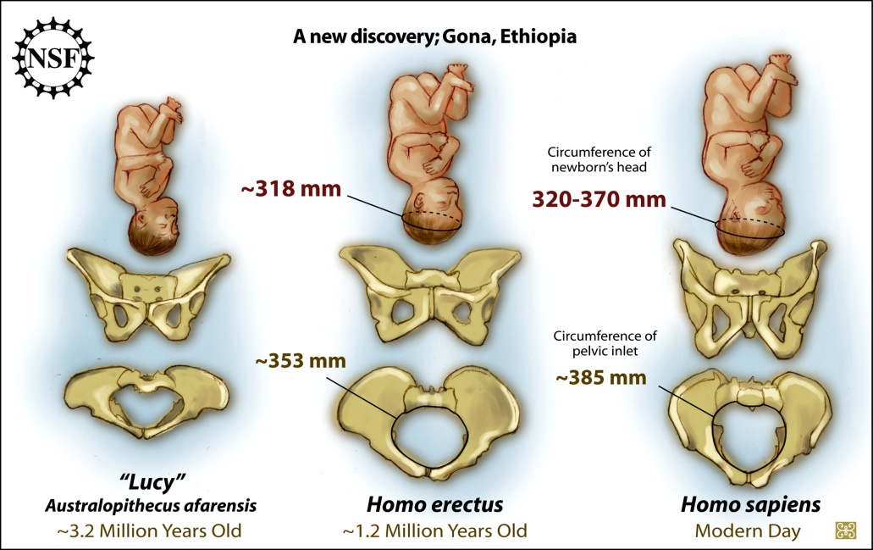
EARTH HISTORY, EVOLUTION & GENETICS

- ICE CORES TRAP GASES & DUST TO TELL US OUR AT _ OS _ H _ _ I _ PAST.
  - climate history

- 2 WAYS we DATE the age of Earth:

RELATIVE DATING RADIOACTIVE DATING
LAW of SUPERPOSTION Unstable atoms break down
(older layer on the _ _ _ _ _ _) Carbon-14
(faults are _______ than layers) Uranium-238
INDEX FOSSILS: More EXACT & PRECISE
widespread/in 1 layer for fossils & rocks than relative
identifies layer across continents dating
UNCONFORMITIES: a.k.a: A____________ DATING
Gap in rock layers where erosion/
catastrophes may have occurred. INDEX FOSSILS too!

(Which way gives scientists APPROXIMATE dating? _____________! Something that has evolved before another creature will be above or below it in the rock layers? ____________)

- Our Earth surface is made of lithospheric plates that slowly, but constantly move over our molten asthenosphere on C_ _ V _ _ _ _ _N CURRENTS.
  - This explains ______________ DRIFT!
    - Plates ______VERGE=Mountains, volcanoes, earthquakes
    - Plates ______VERGE= Spreading ocean centers; thinnest , newest crust
    - Plates TRANSFORM (slide past) = earthquakes, tsunamis

- FAULTS & EARTHQUAKES --evidence that tectonic plates _ _ _ _ constantly!

- Plate Tectonics can ISO_ _ _ _ an organism, so that, over time, it can evolve into another _ _ _CIES.
(Charles __________ saw this in bird finches with different _________ on neighboring Galapagos Islands with different E _ _ _ _ _ _ _ _ _ _ _ _ food sources)

- NUMBER 1 reason for extinction is E _ _ _ R _ _ M _ _ _ _ L CHANGE!!!!
(EXTINCTION is C_ _ _ _ N. Most life around 1 mya are not here today. Some disappeared completely while others slowly E_ _ _ _ _ _ into a new, more successful species with better fitting traits called: A _ _ _ _ _ _ _ _ _ _)
(Extinction is natural and increasingly _ _ _ -made!) (GEOLOGIC TIME SCALE is divided by _ _ _ _ extinctions!)
(The FIRST 4 billion years of Earth’s history is called the P _ _ C _ _ _ _ _ _ _ EON & had only _ _ _ cellular stuff.)

- HOW does NATURE PREVENT EXTINCTION? through _ _ N _ _ _ _ _ _!!!
- GENETICS—G_ _ _ _ equip life with all sorts of t_ _ _ _ s to survive all sorts of conditions.
- GENETICS---explains how we come in all sorts of shapes and sizes (V_ R _ AT _ _ _).
- GENETICS-- genetic D_ V _ _ _ ITY ensures that someone will be able to survive any environmental condition.

- 5 EVIDENCES of BIO EVOLUTION:
- FOSSILS!!
  - LAW of SUPERPOSITION -- more fossils that resemble existing species are closer to the _____.
  - TRANSITIONAL FOSSILS -- Fossils from rock layer to rock layers that show the slow evolutionary C _ _ _ _ _ of a species like horses.
- SIMILAR BODY STRUCTURES & ANATOMIES – so much life have similar organ systems, skeletal systems, etc. SEEN in FOSSILS of COMMON ANCESTORS!
  - H _ M _ L _ G_ _S STRUCTURES have similar purpose & structure. (like 5 fingers in human hands & whale flippers, or eyes with pupils &irises)
  - V _ ST _ _ _ _ L STRUCTURES show organs, structures or behavioral trait that an organism no longer needs but still has (wisdom teeth, appendix, baby’s grip, nictitating membranes, tailbones, etc.)
- DISTRIBUTION of SPECIES – Life on Earth has 5 kingdoms which fill our planet in every environmental N _ C _ _. The longer a continent has been I_____________ from other continents, the more different they are from the rest.
  - Australian Koala and Kangaroos.
- SIMILARITIES in DEVELOPMENT – So much life on Earth begins as similar looking E _ _ _ _ _ _!
- NEW EVIDENCE in MOLECULAR BIOLOGY – Comparing how much _ _ _ organisms share with their closest relatives as well as other organisms.

- What CONCEPT says that the way the world works today has been going on since the beginning of time? (i.e. erosion, convection, water cycle, densities, gravity, electromagnetic waves, chemical reactions, magnetism, etc. have all been working this way since the beginning) The concept of ___________________________.

- Charles Darwin came up with his Theory of N_____________ S_____________ which says that species O ____________ with a V_____________ of traits to evolve slowly over _______ generations with successful A______________ they got from being more successful during C________________.
  - Survival of the “______________” does NOT mean STRONGEST. It means that species more perfectly FITS its N _ _ _ _ in its environment.

http://www.nap.edu/read/6024/chapter/4#21

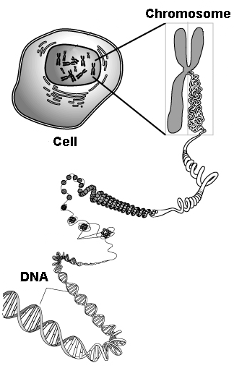

BALL TYPE | MASS (G) | VOLUME:  4/3 x π x r³ | PREDICTED ORDER from HIGH to LOW DENSITIES | ACTUAL  ORDER from  HIGH to LOW DENSITIES
12” SOFTBALL
GOLF BALL
Small, spotted rubber ball
Ol’ collapsing glow ball
Rubber band ball
Brass ball
BASEBALL
ICEBALL
Small plastic marble
FOAM BALL
Glass marble
Lacrosse ball
Wood ball
FOIL BALL
Clay ball
blue rubber basketball
Small red bouncy ball
Mom’s 10 lbs
Bowling ball

